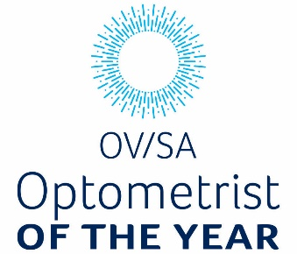
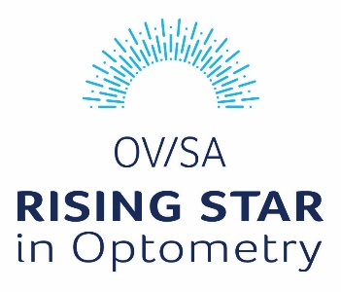

OV/SA Awards Nomination Form
Description of the awards:
Rising Star Award - Early Career Optometrist (up to 10 years from graduation)
or
Optometrist of the Year Award
These awards celebrate any of the wide range of significant contributions that an individual has made to the profession. Examples include:
- member who has been involved in the creation of an innovative or otherwise valuable product, service or knowledge.
- member with an outstanding contribution in areas such as community outreach, climate change and recycling initiatives or Aboriginal and Torres Strait Islander engagement.
Who can nominate
A member of OVSA who is or has been an AHPRA registered Optometrist. Members may self-nominate or be nominated by another OV/SA member; however, the application form must be completed by two independent people (at least one OV/SA member, neither being the nominated person themselves).
Date application sent:

Details of the member to be nominated
Full name
OV/SA Member Number
Address
Mobile
Email
Nominating for which Award? | Rising Star Award Optometrist of the Year Award
Does the nominee have an active disciplinary condition on their AHPRA membership | Y / N
Does the nominee identify as Aboriginal and/or Torres Strait Islander origin? | Aboriginal Torres Strait Islander  Both Neither
Reasons for nomination (please attach additional pages as required):
1. What is your connection with the nominee? Please indicate whether you know this person at a personal level.
2. Please describe the significant contributions of this early career Member to optometry. (limited to 1000 words)
Details of the people nominating
Contact 1
Full name
Address
Mobile
Email
Contact 2
Full name
Address
Mobile
Email

Apart from the two contacts listed, would there be anyone else who would be happy to be contacted regarding this nomination?

