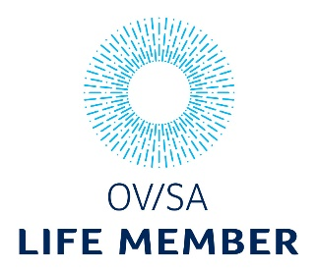

OV/SA Life Member Nomination Form
Description of the award:
Life Members are nominated in recognition of the meritorious contribution of long and distinguished service by the Member to optometry or the profession of optometry.
Examples may include:
- patient service excellence through technical expertise and standard of care, as evidenced by additional qualifications, certifications, patient and/or peer references and the absence of AHPRA notations or complaints.
- impact through innovation (e.g. new product development, protocol development, creative patient service).
- intellectual contribution through teaching and/or research.
- custodianship contribution through support of fellow optometrists (e.g. mentoring) and/or improvement of relations between optometry and associated professions.
- advocacy contribution, increasing the standing of optometry among community, government (e.g. campaigning for expanded funding, scope of practice, professional support).
- community contribution through voluntary outreach and/or sustainability activities.
- evidence of humility, kindness and compassion within practice.
- being a person of high standing within the community, as evidenced by patient and/or peer professional references.
Who can nominate:
A member of OVSA who is or has been an AHPRA registered Optometrist. Members may self-nominate or be nominated by another OV/SA member; however, the application form must be completed by two independent people (at least one OV/SA member, neither being the nominated person).

Date application sent:

Details of the member to be nominated
Full name
OV/SA Member Number
Address
Mobile
Email
Does the nominee have an active disciplinary condition on their AHPRA membership? | Y / N
Does the nominee identify as Aboriginal and/or Torres Strait Islander origin? | Aboriginal Torres Strait Islander  Both Neither

Reasons for nomination (please attach additional pages as required):
1. What is your connection with the nominee? Please indicate whether you know this person at a personal level.
2. Please describe the meritorious contributions of long and distinguished service by the Member to optometry or the profession of optometry. (Limited to 1000 words)

Details of the people nominating
Contact 1
Full name
Address
Mobile
Email
Contact 2
Full name
Address
Mobile
Email

Apart from the two contacts listed, would there be anyone else who would be happy to be contacted regarding this nomination?

