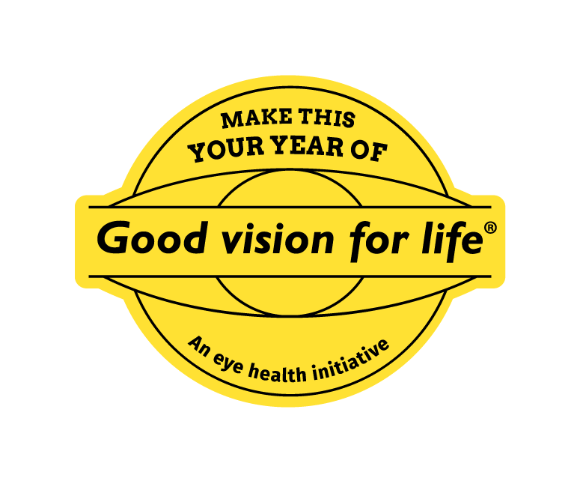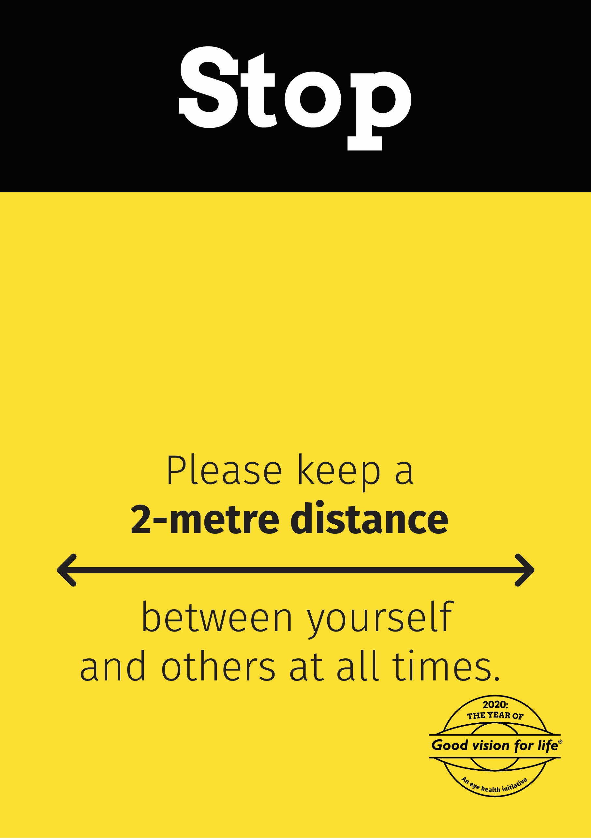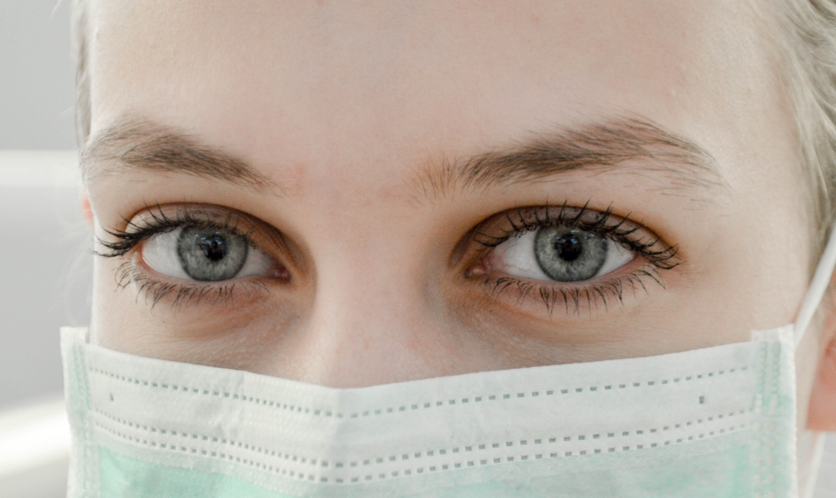

**Please read before entering:**

**Even though mask rules have been relaxed for retail, under State Government rules A MASK IS STILL REQUIRED for all healthcare settings**

Updated 15 March 2022