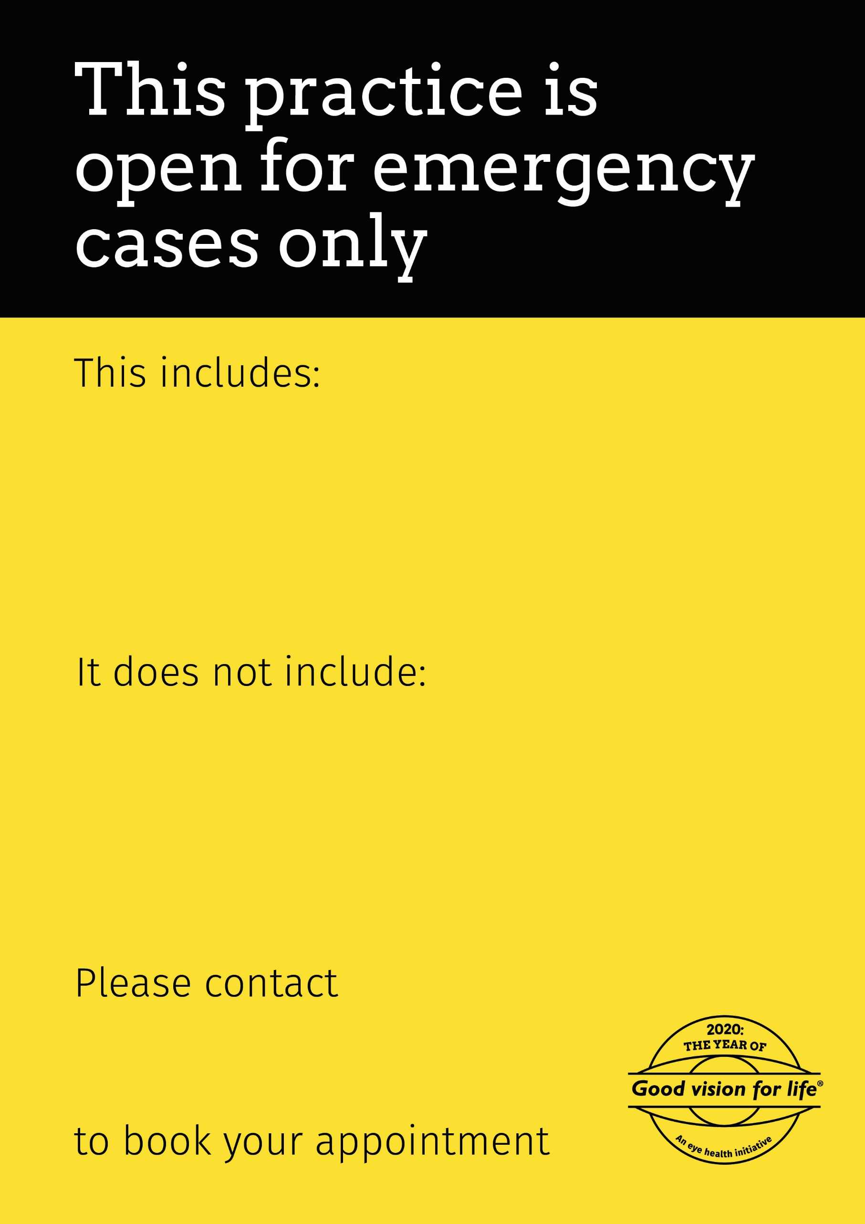

Insert contact details here

Regular check-ups if you are not experiencing any new signs or symptoms

If you have eye pain or discomfort, recent change in vision, flashes of lights, new floaters in your vision, new onset double vision or recent eye trauma. Also, if you have eye or vision issues that are impacting your ability to function day to day (e.g. driving, reading, mobility or working).