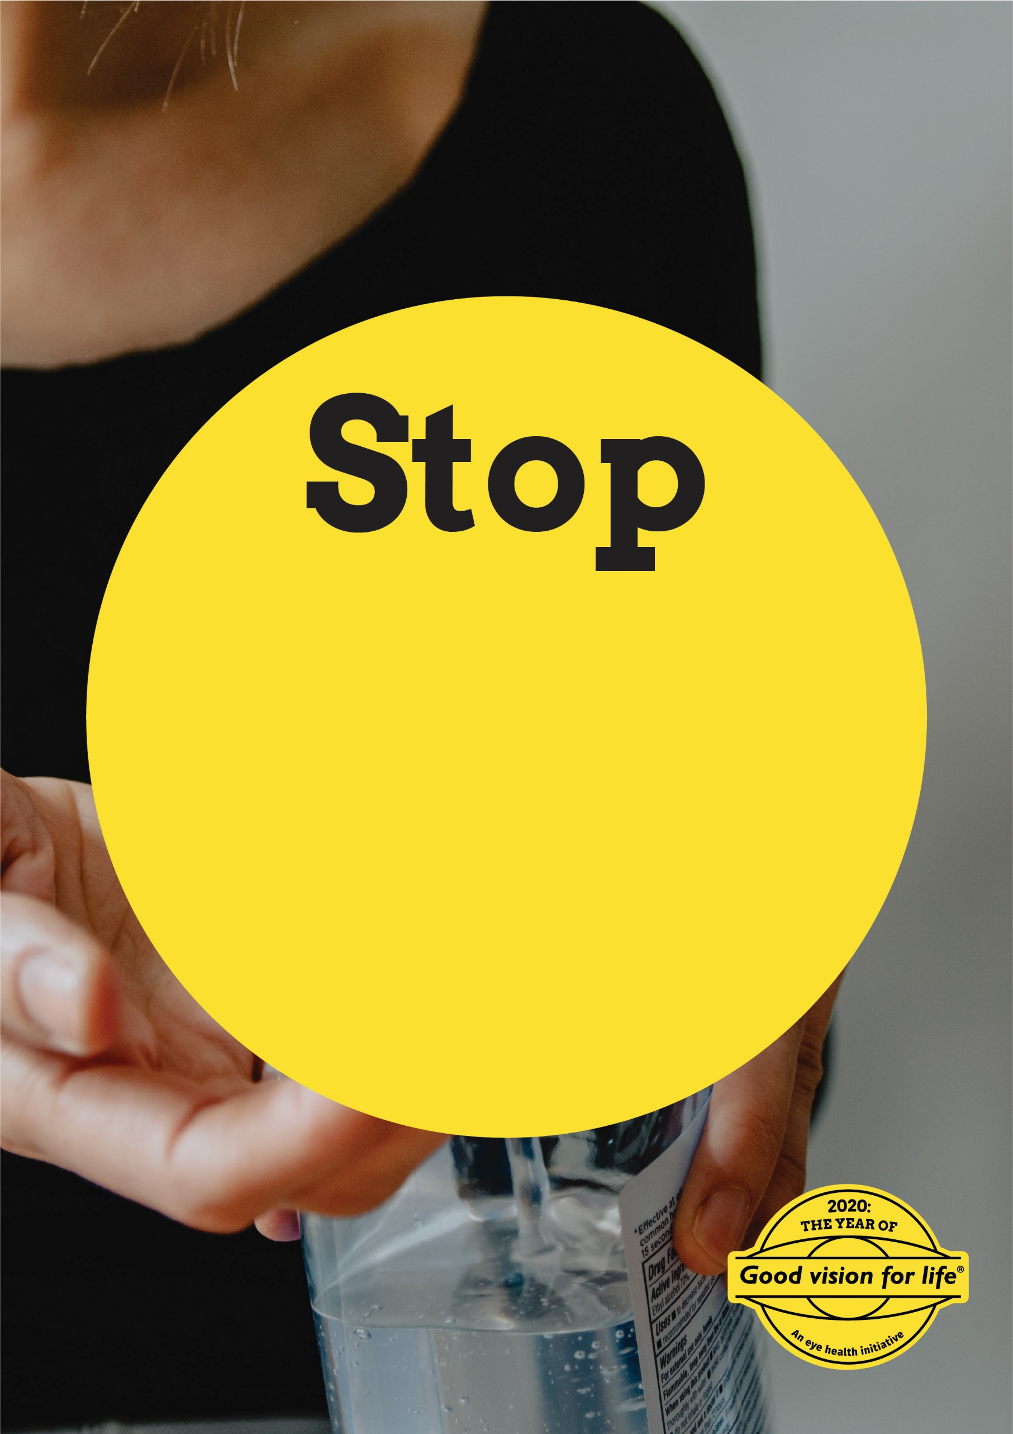

**Please sanitise your hands before entering the practice**

Enter additional instructions here if required