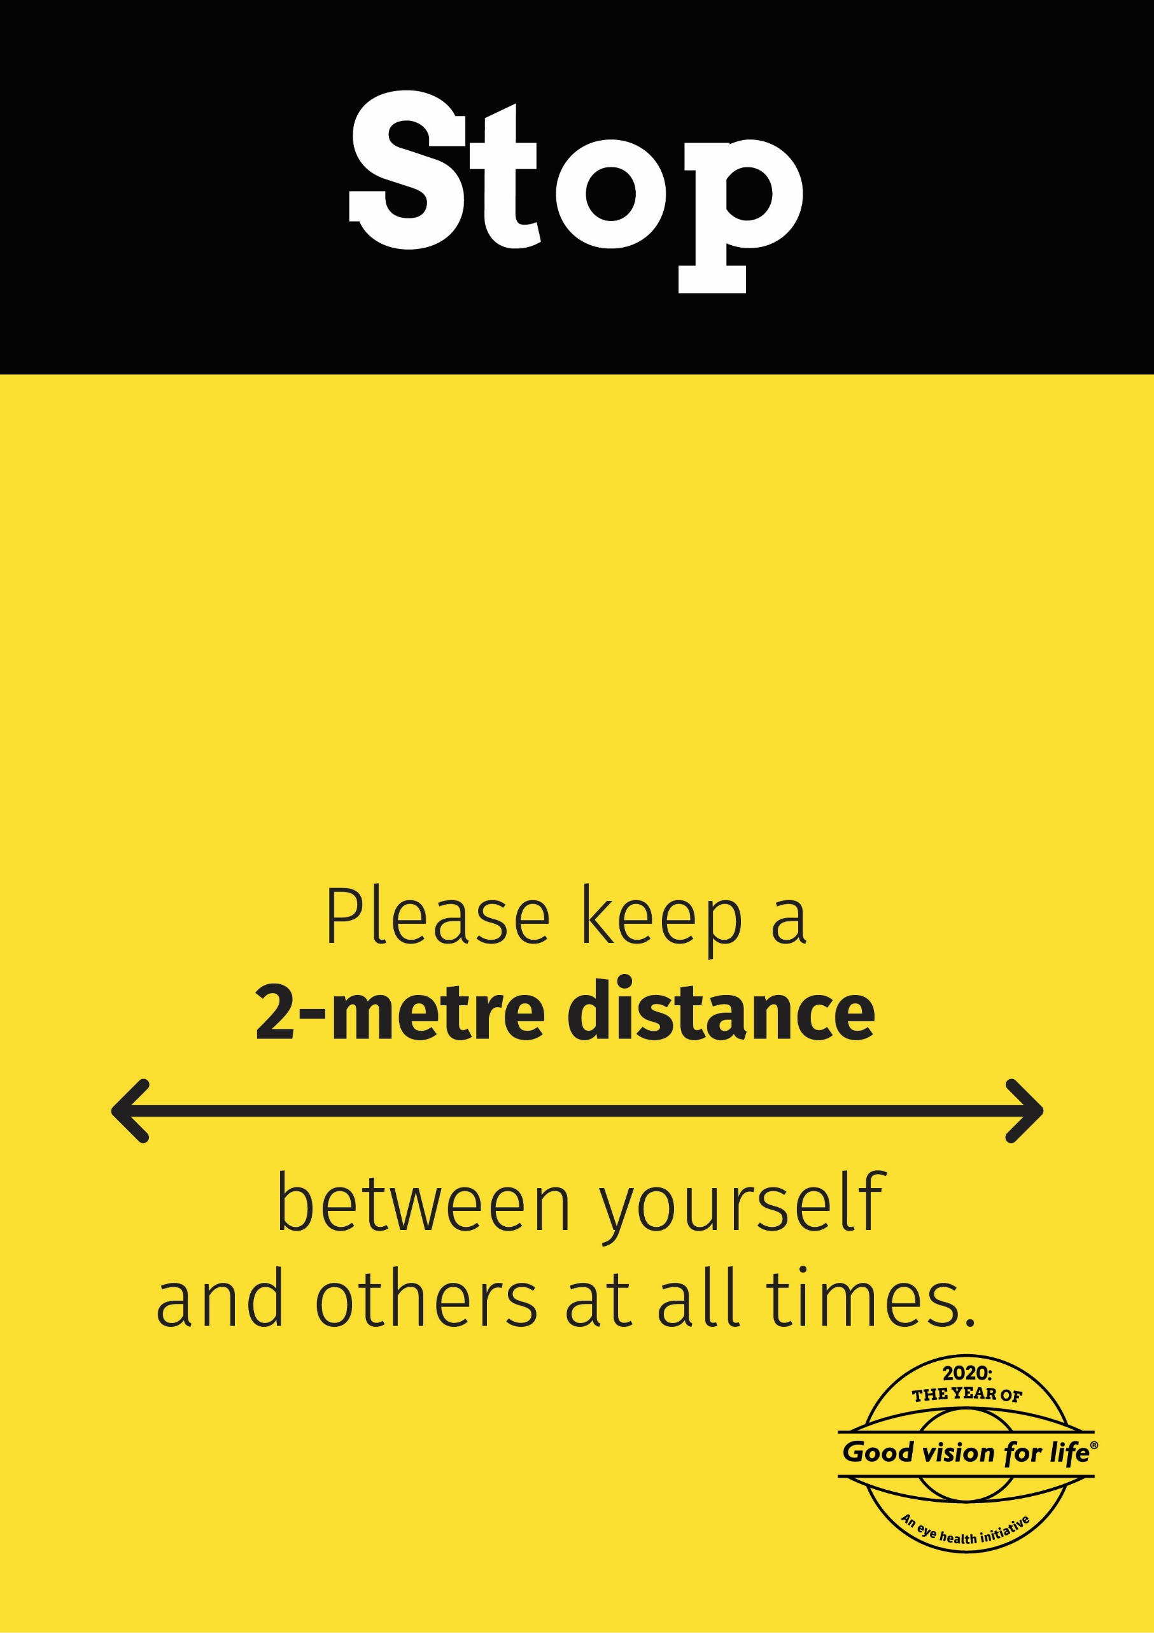

**If there are already two (2) customers inside, please wait for one to leave before entering**