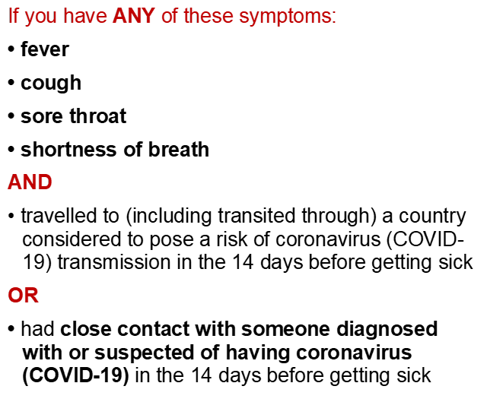

**Please present to reception immediately**,   
notify them of any of the above symptoms and any recent travel.

Updated 12 March 2020

Your logo here

**We may request that you postpone your appointment today and seek medical attention.**

**PATIENT ALERT**

**Please read this before entering the waiting room**