OPTOMETRY VICTORIA SOUTH AUSTRALIA
Annual Golf Day - Monday 28 March, 2022
Peninsula Kingswood Country Golf Club

Optometry Victoria South Australia (OV/SA) members and guests are invited to join us for a game of golf on the prestigious Peninsula Kingswood Country Golf Club. OV/SA’s annual golf day aims to raise funds for charity to improve eye health outcomes for disadvantaged communities.

Peninsula Kingswood Country Golf Club is an elite club that offers the very best golf with state of the art facilities and is located 35 minutes’ drive from Melbourne in the Frankston/Peninsula region. Our event will be held on the south course at the club which is ranked 20th in Victoria.

This social golf day is in its 99th year and is open to beginners through to the experienced golfer. The program includes individual Stableford and Ambrose events with plenty of prizes on offer and the opportunity to get your name on the prestigious perpetual golf day trophy.
The Golf Day Program  - Register Individually or groups of four  - Registration opens 10.00am on the day  - Round of 18 – shot gun start at 12.30pm  - Field limited to 100 players  - Pro Golfer on course  Included in ticket price  - Green fees  - Lunch on arrival  - Cocktail function  - Professional golfer challenge  - Trophies and awards presentation  - Lots of prizes to be won |  | Golf Day Fee  OV/SA Members $160  Non OV/SA Members $220  To Register:  Complete the registration form and email to  l.busuttil@optometry.org.au  Or call Lisa on 03 9652 9100

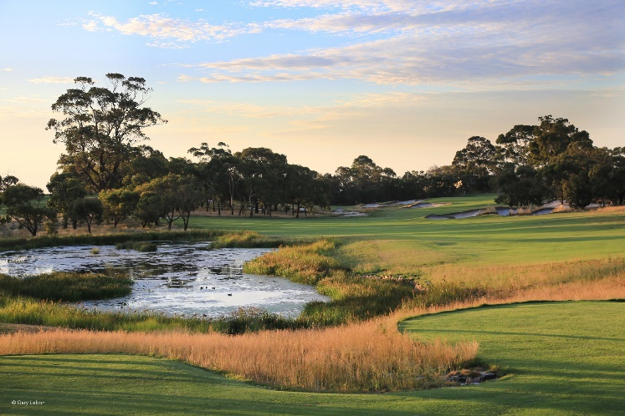

REGISTRATION FORM - OV/SA ANNUAL GOLF DAY
Monday 28 March, 2022 – Kingswood Peninsula Country Golf Club
Golf Fee includes Green Fees, light lunch and evening Cocktail Function

Player 1 - Name: Click here to enter text. OA Member Number: Click here to enter text. Address: Click here to enter text.
Mobile: Click here to enter text. Email: Click here to enter text.
GA Number: Click here to enter text. Handicap: Click here to enter text.
Affiliation (Please tick one): ☐ Optometrist ☐ Optical Industry ☐ Other
Competition: ☐ Stableford OR ☐ Ambrose
Player 2 - Name: Click here to enter text. OA Member Number: Click here to enter text. Address: Click here to enter text.
Mobile: Click here to enter text. Email: Click here to enter text.
GA Number: Click here to enter text. Handicap: Click here to enter text.
Affiliation (Please tick one): ☐ Optometrist ☐ Optical Industry ☐ Other
Competition: ☐ Stableford OR ☐ Ambrose
Player 3 - Name: Click here to enter text. OA Member Number: Click here to enter text. Address: Click here to enter text.
Mobile: Click here to enter text. Email: Click here to enter text.
GA Number: Click here to enter text. Handicap: Click here to enter text.
Affiliation (Please tick one): ☐ Optometrist ☐ Optical Industry ☐ Other
Competition: ☐ Stableford OR ☐ Ambrose
Player 4 - Name: Click here to enter text. OA Member Number: Click here to enter text. Address: Click here to enter text.
Mobile: Click here to enter text. Email: Click here to enter text.
GA Number: Click here to enter text. Handicap: Click here to enter text.
Affiliation (Please tick one): ☐ Optometrist ☐ Optical Industry ☐ Other
Competition: ☐ Stableford OR ☐ Ambrose

PAYMENT DETAILS
Please charge my: ☐ Visa ☐ Mastercard Amount $ Click here to enter text.
Card Number: Click here to enter text.
CVV: Click here to enter text. Expiry Date: Click here to enter text.
Cardholder’s Name: Click here to enter text.

